

**WINTER SEMESTER 2020-21 SLOT: C1**

**CSE3013-ARTIFICIAL INTELLIGENCE**

**THEORY DIGITAL ASSESSMENT-I**

**Question 1:**

**Using A* Algorithm, find the optimal path from the node S for the graph given in the diagram. Two goal nodes are given in the diagram. Explain how the algorithm can/cannot find the optimal solution for both goal nodes.**

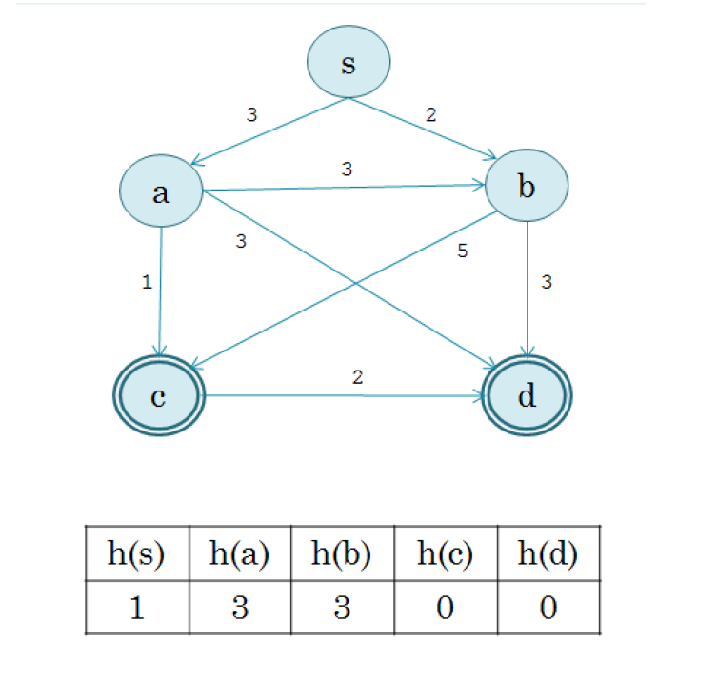

**Solution 1)**

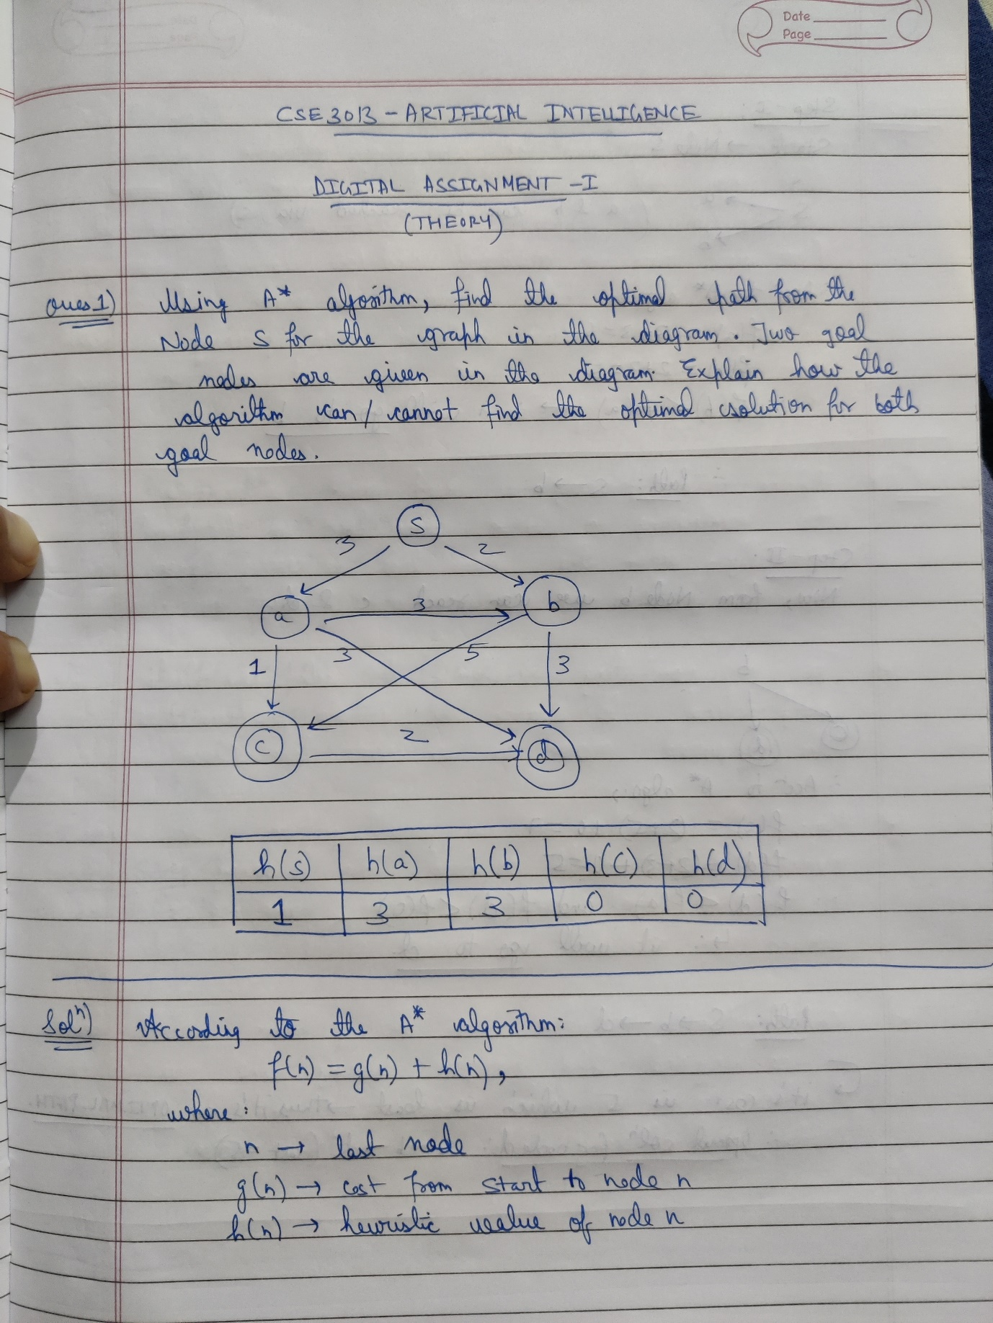

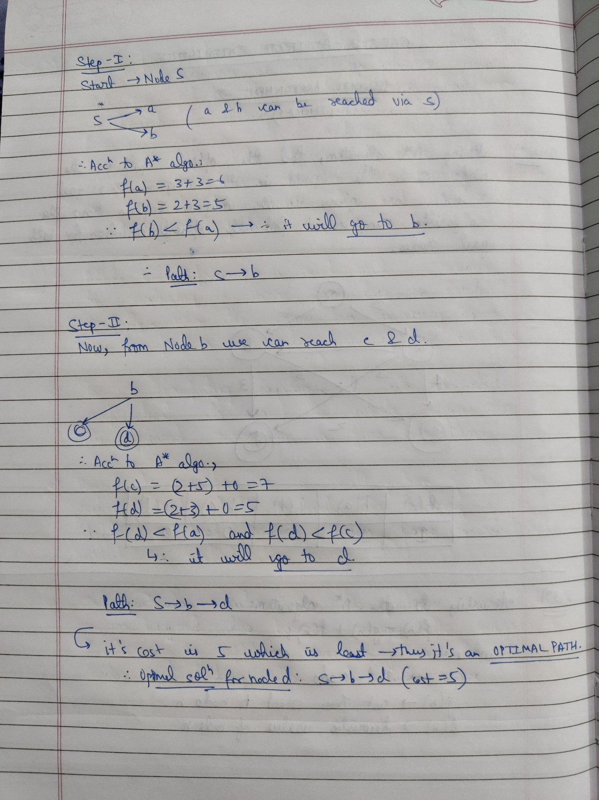

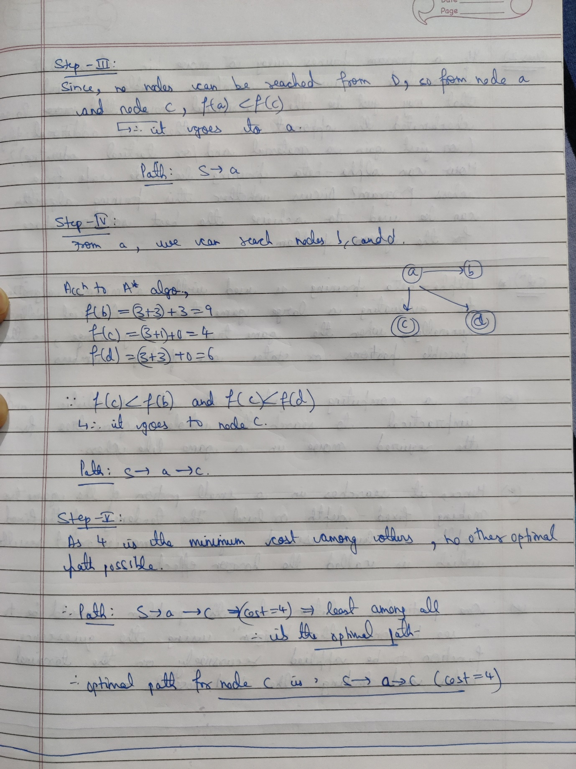

**Question 2:**

**If a program prunes away a move in chess that looks bad because it sacrifices valuable material that may just be the sacrificial move that would have checkmated the opponent in another few additional ply (or just gain a material and/or tactical advantage)? How can alpha-beta pruning be made safe for a chess program? Discuss whether this pruning algorithm can be used to achieve the best solution space for the given problem.**

**Solution 2)**

